**Name: Vivek Pandey**

**Topics: Normal distribution, Functions of Random Variables**

1. The time required for servicing transmissions is normally distributed with *m* = 45 minutes and *s* = 8 minutes. The service manager plans to have work begin on the transmission of a customer’s car 10 minutes after the car is dropped off and the customer is told that the car will be ready within 1 hour from drop-off. What is the probability that the service manager cannot meet his commitment?
2. 0.3875
3. 0.2676
4. 0.5
5. 0.6987

Ans: B

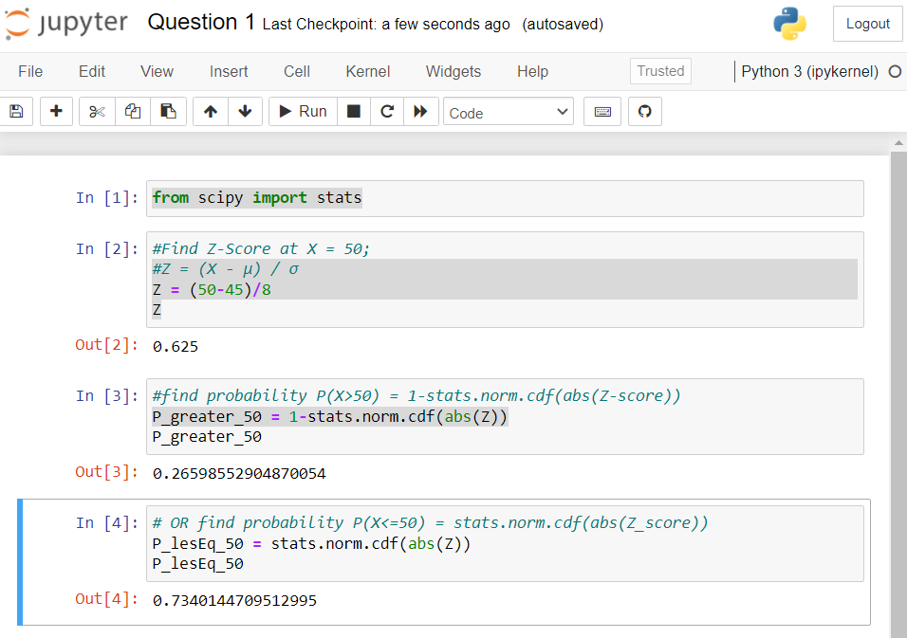

1. The current age (in years) of 400 clerical employees at an insurance claims processing center is normally distributed with mean *m* = 38 and Standard deviation *s* =6. For each statement below, please specify True/False. If false, briefly explain why.
2. More employees at the processing center are older than 44 than between 38 and 44.
3. A training program for employees under the age of 30 at the center would be expected to attract about 36 employees.

**Ans:** 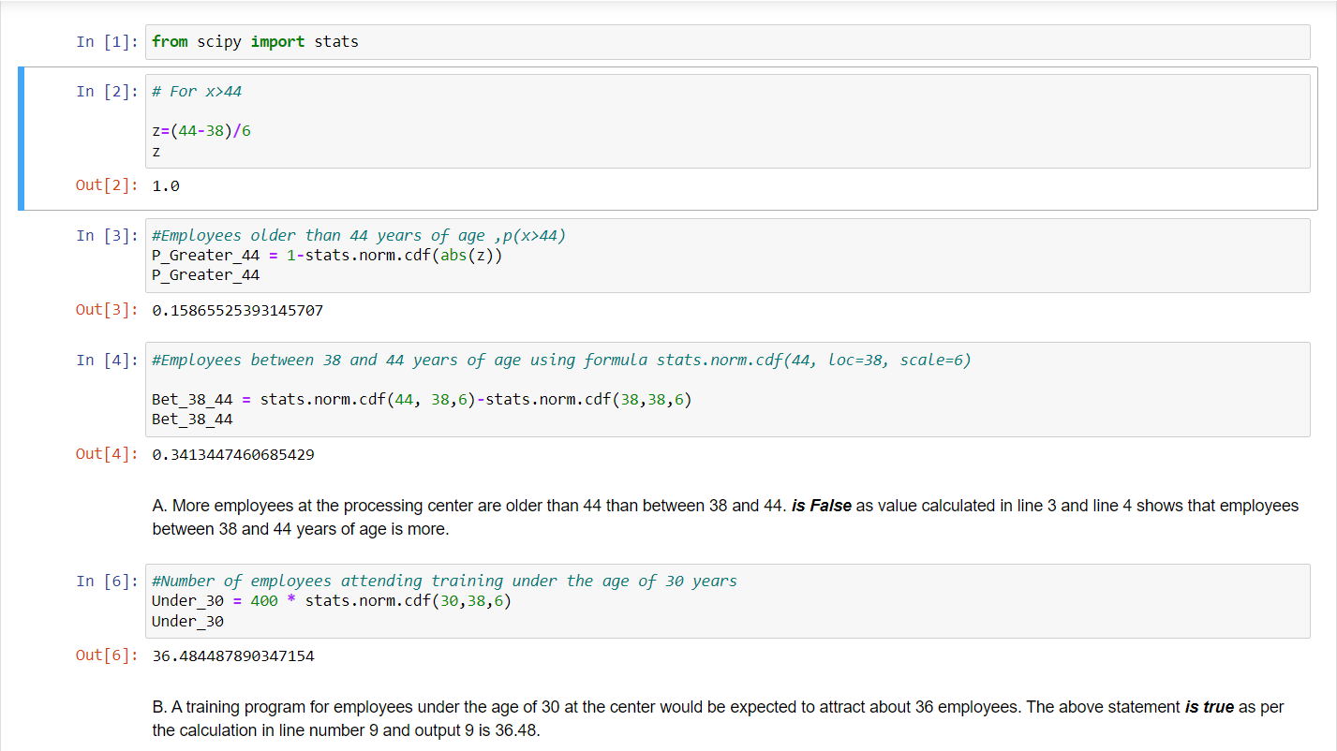

1. If *X1* ~ *N*(μ, σ2) and *X*2 ~ *N*(μ, σ2) are *iid* normal random variables, then what is the difference between 2 *X*1 and *X*1 + *X*2? Discuss both their distributions and parameters.

**Ans:** As we know that if X ∼ N(µ1, σ1^2 ), and Y ∼ N(µ2, σ2^2 ) are two independent random variables then X + Y ∼ N(µ1 + µ2, σ1^2 + σ2^2 ) , and X − Y ∼ N(µ1 − µ2, σ1^2 + σ2^2 ) .

Similarly if Z = aX + bY , where X and Y are as defined above, i.e Z is linear combination of X and Y , then Z ∼ N(aµ1 + bµ2, a^2σ1^2 + b^2σ2^2 ).

Therefore in the question,

2X1~ N(2 u,4 σ^2) and X1+X2 ~ N(µ + µ, σ^2 + σ^2 ) ~ N(2 u, 2σ^2 )

2X1-(X1+X2) = N( 4µ,6 σ^2)

1. Let X ~ N(100, 202). Find two values, *a* and *b*, symmetric about the mean, such that the probability of the random variable taking a value between them is 0.99.
2. 90.5, 105.9
3. 80.2, 119.8
4. 22, 78
5. 48.5, 151.5
6. 90.1, 109.9

Ans: 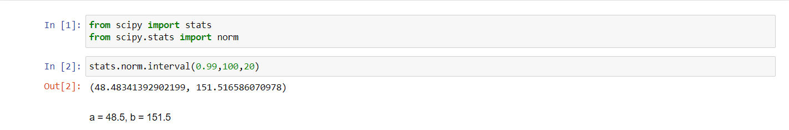

1. Consider a company that has two different divisions. The annual profits from the two divisions are independent and have distributions Profit1 ~ N(5, 32) and Profit2 ~ N(7, 42) respectively. Both the profits are in $ Million. Answer the following questions about the total profit of the company in Rupees. Assume that $1 = Rs. 45
2. Specify a Rupee range (centered on the mean) such that it contains 95% probability for the annual profit of the company.
3. Specify the 5th percentile of profit (in Rupees) for the company
4. Which of the two divisions has a larger probability of making a loss in a given year?

Ans:

**import** numpy **as** np

**from** scipy **import** stats

**from** scipy.stats **import** norm

*# Mean profits from two different divisions of a company = Mean1 + Mean2*Mean **=** 5**+**7print('Mean Profit is Rs', Mean**\***45,'Million')

Mean Profit is Rs 540 Million

*# Variance of profits from two different divisions of a company = SD^2 = SD1^2 + SD2^2*SD **=** np.sqrt((9)**+**(16))print('Standard Deviation is Rs', SD**\***45, 'Million')

Standard Deviation is Rs 225.0 Million

**A. Specify a Rupee range (centered on the mean) such that it contains 95% probability for the annual profit of the company.**

print('Range is Rs',(stats.norm.interval(0.95,540,225)),'in Millions')

Range is Rs (99.00810347848784, 980.9918965215122) in Millions

**B. Specify the 5th percentile of profit (in Rupees) for the company.**

*# To compute 5th Percentile, we use the formula X=μ + Zσ; wherein from z table, 5 percentile = -1.645*X**=** 540**+**(**-**1.645)**\***(225)print('5th percentile of profit (in Million Rupees) is',np.round(X,))

5th percentile of profit (in Million Rupees) is 170.0

**C. Which of the two divisions has a larger probability of making a loss in a given year?**

*# Probability of Division 1 making a loss P(X<0)*stats.norm.cdf(0,5,3)

0.0477903522728147

*# Probability of Division 2 making a loss P(X<0)*stats.norm.cdf(0,7,4)

0.040059156863817086

**Division 1 has a larger probability of making a loss in a given year.**